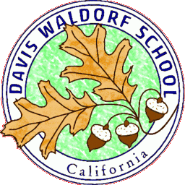
Job Posting for Davis Waldorf School3100 Sycamore Ln., Davis, CA 95616 Fax: 530-753-0944

Grades Class Teacher for the 2020-2021 School Year
Are you passionate about working withchildren? We are looking for a Waldorf trained individual to join our Faculty as a Grades Teacher, for the upcoming school year. This is a full time, benefitted position.
The Teacher will work to deliver a Waldorf grades curriculum.We are looking for a teacher who has strong communication skills, knowledge of child development, and an interest in implementing curriculum and activities. Waldorf training or experience is required and a Bachelor’s Degree.
Applicants should enjoy working with a team, be willing to take on new responsibilities and classroom chores, be prepared for a physically active school day (outside, in all weather conditions), enjoy supervising children, and be flexible with their work schedule as needed.
Our school offers a Waldorf curriculum for 1st through 8th grade, a licensed child care center that has two preschools, two Kindergartens and an after school program. We have a strong and experienced faculty dedicated to working out of Anthroposophy. Our parents are invested in their children's education and in the school, bringing great enthusiasm and energy to any project. We are accredited by and a full member school of AWSNA [Association of Waldorf Schools of North America] and WECAN [Waldorf Early Childhood Association of North America].
REQUIRED CERTIFICATES, LICENSES, and REGISTRATIONS: Waldorf teacher training certificate. Bachelor’s Degree.Must pass Department of Justice (DOJ), Federal Bureau of Investigations (FBI) and Child Abuse Reference Check (CAIC) background clearance. Compensation: Salaried, and competitive. Varies depending upon experience and qualifications.Current TB test results. Candidate must also be CPR certified and provide proof of Child Abuse Prevention training. Candidate must undergo a Live Scan (fingerprinting) and a background check prior to being hired.
To apply, complete a DWS school application (found on our website, www.daviswaldorf.org, Job Openings), submit your resume, a cover letter stating why you are a suitable candidate for this position, and a list of three references (with e-mail addresses) to the Davis Waldorf School at: recruitment@daviswaldorf.org

